A* Search Algorithm
Aim
To find the shortest path from a start node to a goal node using a heuristic function that estimates the cost to reach the goal.

Python Program
import heapq

def a_star(graph, start, goal, heuristic):
open_list = [(0, start)]
g_cost = {start: 0}
parent = {start: None}

while open_list:
_, current = heapq.heappop(open_list)

if current == goal:
path = []
while current:
path.append(current)
current = parent[current]
return path[::-1]

for neighbor, cost in graph[current]:
new_cost = g_cost[current] + cost

if neighbor not in g_cost or new_cost < g_cost[neighbor]:
g_cost[neighbor] = new_cost
f_cost = new_cost + heuristic[neighbor]
heapq.heappush(open_list, (f_cost, neighbor))
parent[neighbor] = current

return None

graph = {
'A': [('B', 1), ('C', 4)],
'B': [('D', 2), ('E', 5)],
'C': [('F', 3)],
'D': [('G', 1)],
'E': [('G', 2)],
'F': [('G', 2)],
'G': []
}

heuristic = {
'A': 7,
'B': 6,
'C': 4,
'D': 2,
'E': 1,
'F': 2,
'G': 0
}

path = a_star(graph, 'A', 'G', heuristic)

print("Shortest Path:", " -> ".join(path))

Output
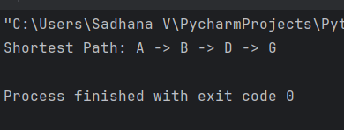
Flowchart
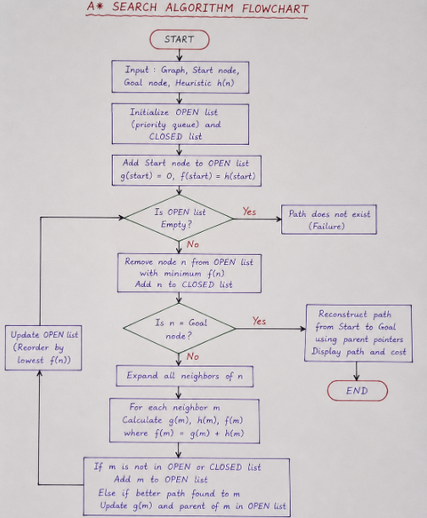
Result
Thus, the A* Search Algorithm was implemented successfully in Python. The shortest path obtained from the start node to the goal node is:

